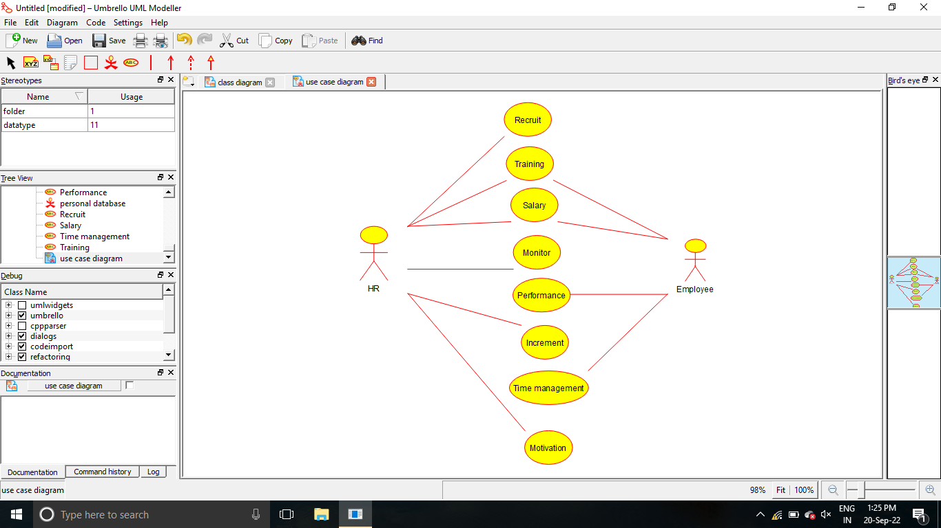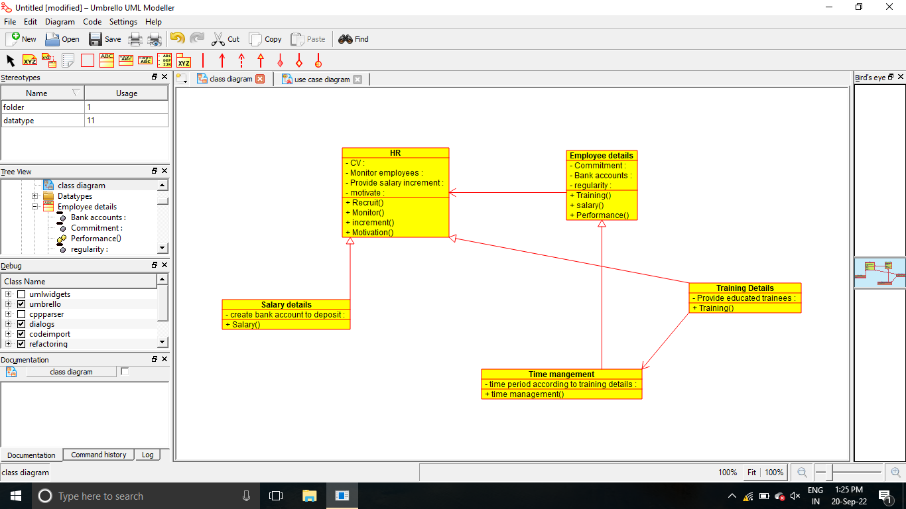

/**

 * Class Employee_details

 */

public class Employee_details {

  //

  // Fields

  //

  private void Commitment;

  private void Bank_accounts;

  private void regularity;

  //

  // Constructors

  //

  public Employee_details () { };

  //

  // Methods

  //

  //

  // Accessor methods

  //

  /**

   * Set the value of Commitment

   * @param newVar the new value of Commitment

   */

  private void setCommitment (void newVar) {

    Commitment = newVar;

  }

  /**

   * Get the value of Commitment

   * @return the value of Commitment

   */

  private void getCommitment () {

    return Commitment;

  }

  /**

   * Set the value of Bank_accounts

   * @param newVar the new value of Bank_accounts

   */

  private void setBank_accounts (void newVar) {

    Bank_accounts = newVar;

  }

  /**

   * Get the value of Bank_accounts

   * @return the value of Bank_accounts

   */

  private void getBank_accounts () {

    return Bank_accounts;

  }

  /**

   * Set the value of regularity

   * @param newVar the new value of regularity

   */

  private void setRegularity (void newVar) {

    regularity = newVar;

  }

  /**

   * Get the value of regularity

   * @return the value of regularity

   */

  private void getRegularity () {

    return regularity;

  }

  //

  // Other methods

  //

  /**

   */

  public void Training()

  {

  }

  /**

   */

  public void salary()

  {

  }

  /**

   */

  public void Performance()

  {

  }

}

/**

 * Class Salary_details

 */

public class Salary_details extends HR {

  //

  // Fields

  //

  private void create_bank_account_to_deposit;

  //

  // Constructors

  //

  public Salary_details () { };

  //

  // Methods

  //

  //

  // Accessor methods

  //

  /**

   * Set the value of create_bank_account_to_deposit

   * @param newVar the new value of create_bank_account_to_deposit

   */

  private void setCreate_bank_account_to_deposit (void newVar) {

    create_bank_account_to_deposit = newVar;

  }

  /**

   * Get the value of create_bank_account_to_deposit

   * @return the value of create_bank_account_to_deposit

   */

  private void getCreate_bank_account_to_deposit () {

    return create_bank_account_to_deposit;

  }

  //

  // Other methods

  //

  /**

   */

  public void Salary()

  {

  }

}

/**

 * Class HR

 */

public class HR {

  //

  // Fields

  //

  private void CV;

  private void Monitor_employees;

  private void Provide_salary_increment;

  private void motivate;

  //

  // Constructors

  //

  public HR () { };

  //

  // Methods

  //

  //

  // Accessor methods

  //

  /**

   * Set the value of CV

   * @param newVar the new value of CV

   */

  private void setCV (void newVar) {

    CV = newVar;

  }

  /**

   * Get the value of CV

   * @return the value of CV

   */

  private void getCV () {

    return CV;

  }

  /**

   * Set the value of Monitor_employees

   * @param newVar the new value of Monitor_employees

   */

  private void setMonitor_employees (void newVar) {

    Monitor_employees = newVar;

  }

  /**

   * Get the value of Monitor_employees

   * @return the value of Monitor_employees

   */

  private void getMonitor_employees () {

    return Monitor_employees;

  }

  /**

   * Set the value of Provide_salary_increment

   * @param newVar the new value of Provide_salary_increment

   */

  private void setProvide_salary_increment (void newVar) {

    Provide_salary_increment = newVar;

  }

  /**

   * Get the value of Provide_salary_increment

   * @return the value of Provide_salary_increment

   */

  private void getProvide_salary_increment () {

    return Provide_salary_increment;

  }

  /**

   * Set the value of motivate

   * @param newVar the new value of motivate

   */

  private void setMotivate (void newVar) {

    motivate = newVar;

  }

  /**

   * Get the value of motivate

   * @return the value of motivate

   */

  private void getMotivate () {

    return motivate;

  }

  //

  // Other methods

  //

  /**

   */

  public void Recruit()

  {

  }

  /**

   */

  public void Monitor()

  {

  }

  /**

   */

  public void increment()

  {

  }

  /**

   */

  public void Motivation()

  {

  }

}